Python pricing engine script

1. Price Prediction Model of AIRBNB Dataset

Import the Libraries

import pandas as pd

import numpy as np

import matplotlib.pyplot as plt

import matplotlib.image as mpimg

%matplotlib inline

import seaborn as sns

import warnings

warnings.filterwarnings('ignore')

import scipy as spy

Import the dataset

airbnb=pd.read_csv('D:\intership\Airbnb_Data.csv')

Shape of the dataset

airbnb.shape

1. Descriptive analysis of the dataset

all_columns=airbnb.columns

print('All columns of the Airbnb dataset')

for column in all_columns:

print(column)

Checking the variables types

These are divided into two types

1. Numeric data -Continuous data,Discrete data
2. Categorical data-ordinal data,Nominal data

Categorical data

print('This is categorical data ')

print('------------------------------')

uni_nhood=airbnb['neighbourhood'].unique()

uni_room_type=airbnb['room_type'].unique()

uni_instant_bookable=airbnb['instant_bookable'].unique()

print('1. Neighbourhood :')

for neighbourhood in uni_nhood:

print(neighbourhood)

print('-----------------------------------------')

print('2. Room_types : ')

for room_type in uni_room_type:

print(room_type)

print('-------------------------------------------')

print('3. Instant_bookable:')

for instant_bookable in uni_instant_bookable:

print(instant_bookable)

Numeric data

numercial_cols=airbnb.select_dtypes(include='number').columns

discrete_numercial_cols=[ "log_price","accommodates", "bedrooms","bathrooms"

, "number_of_reviews","latitude" , "longitude"]

continuous_numercial_cols=[col for col in numercial_cols if col not in discrete_numercial_cols]

print('This is the Numercial Data columns')

print('-------------------------------------------')

print('Discrete Numercial Data:')

for column in discrete_numercial_cols:

uni_values=airbnb[column].unique()

uni_values_str=','.join(map(str,uni_values))

print(f"{column}={uni_values_str}")

print('-----------------------------------------------------------------')

print('Continuous Numercial Data :')

for column in discrete_numercial_cols:

if col=='log_price':

min_value=airbnb[column].min()

max_value=airbnb[column].max()

print(f"{column}:Min={min_value},Max={max_value}")

elif col=='accommodates':

min_value=airbnb[column].min()

max_value=airbnb[column].max()

print(f"{column}:Min={min_value},Max={max_value}")

elif col=='bedrooms':

min_value=airbnb[column].min()

max_value=airbnb[column].max()

print(f"{column}:Min={min_value},Max={max_value}")

elif col=='bathrooms':

min_value=airbnb[column].min()

max_value=airbnb[column].max()

print(f"{column}:Min={min_value},Max={max_value}")

elif col=='number_of_reviews':

min_value=airbnb[column].min()

max_value=airbnb[column].max()

print(f"{column}:Min={min_value},Max={max_value}")

elif col=='longitude':

min_value=airbnb[column].min()

max_value=airbnb[column].max()

print(f"{column}:Min={min_value},Max={max_value}")

else:

min_value=airbnb[column].min()

max_value=airbnb[column].max()

print(f"{column}:Min={min_value},Max={max_value}")

Frequency Distribution

freq_area=airbnb['neighbourhood'].value_counts().reset_index()

freq_area.columns=['neighbourhood','Frequency']

freq_area['Percent']=(freq_area['Frequency']/len(airbnb))*100

freq_area=freq_area.sort_values(by='Frequency')

freq_area=freq_area.reset_index(drop=True)

print(freq_area)

room_type=airbnb['room_type'].value_counts().reset_index()

room_type.columns=['room_type','Frequency']

room_type['Precent']=(room_type['Frequency']/len(airbnb))*100

room_type=room_type.sort_values(by='Frequency')

room_type=room_type.reset_index(drop=True)

print(room_type)

Conclusion form the Frequency Distribution

airbnb.head()

airbnb.describe()

airbnb.info()

Checking for null values

airbnb.isnull().sum()

def nulls_summary_table(airbnb):

null_values=pd.DataFrame(airbnb.isnull().sum())

null_values[1]=null_values[0]/len(airbnb)

null_values.columns=['null_count','null_percent']

return null_values

nulls_summary_table(airbnb)

Drop the unnecessary columns

airbnb_copy=airbnb

airbnb_copy.drop(['id','last_review'],axis=1,inplace=True)

Check the changes

airbnb_copy.head()

airbnb_copy.fillna({'number_of_reviews':0},inplace=True)

airbnb_copy.isnull().sum().sum()

Remove the NAN values from the dataset

airbnb_copy.isnull().sum()

airbnb_copy.dropna(how='any',inplace=True)

Lets finally check the Results

airbnb.info()

Removing where the price equal to 0

airbnb_copy=airbnb_copy[airbnb_copy['log_price']!=0]

airbnb_copy.head()

zero_price_count=airbnb_copy[airbnb_copy['log_price']==0].count()['log_price']

print(zero_price_count)

* 1. Data Visualizations

Heatmap-get correlation between different variables

corr=airbnb_copy.corr(method='kendall',numeric_only=True)

plt.figure(figsize=(15, 8))

sns.heatmap(corr, annot=True, )

airbnb.columns

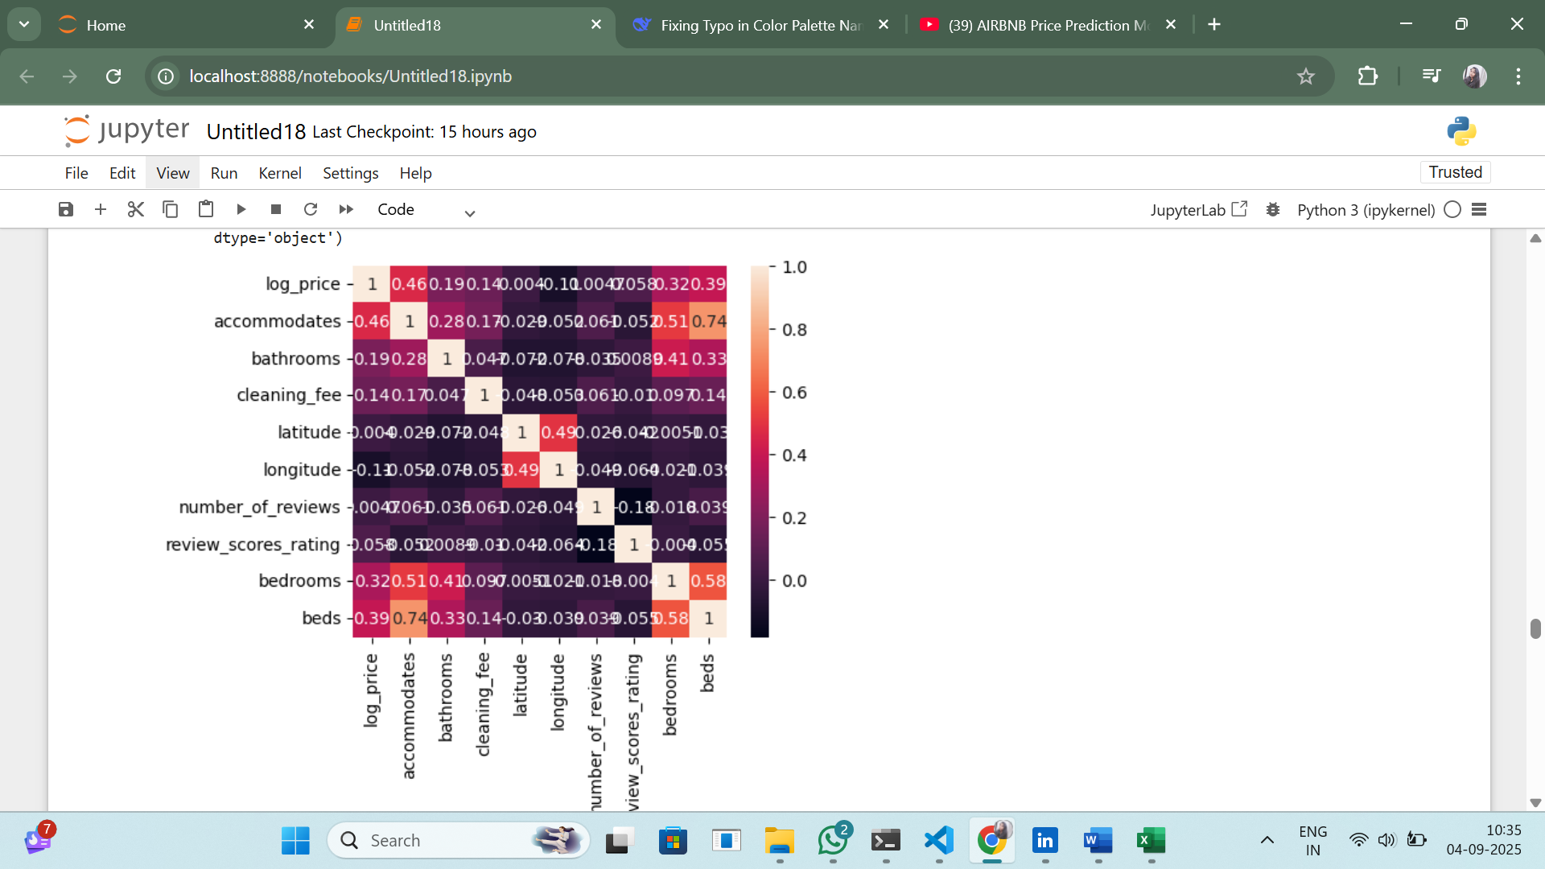

Checking the effect of variables on the price(compare the effect on the model by the other variables and checking which is important parameter to describe the model)

Room_Type

sns.countplot(data=airbnb_copy,x='room_type')

plt.title('room_type')

fig=plt.gcf()

fig.set_size_inches(6,5)

plt.show()

print("After this we check the relation of the price w.r.t to room_type")

median_color="red"

plt.figure(figsize=(12,6))

ax=sns.boxplot(data=airbnb,x='room_type',y='log_price',

boxprops={'edgecolor':median_color},

flierprops={'marker':'o','markerfacecolor':'purple','markeredgecolor':'purple'},

medianprops={'color':median_color,'linewidth':2})

plt.title('Price Distribution by Room Type')

plt.xticks(rotation=45)

medians=airbnb.groupby(['room_type'])['log_price'].median()

for xtick in ax.get_xticks():

ax.text(xtick,medians[xtick],f'{medians[xtick]:.2f}',horizontalalignment='center',color='black',weight='bold')

plt.show()

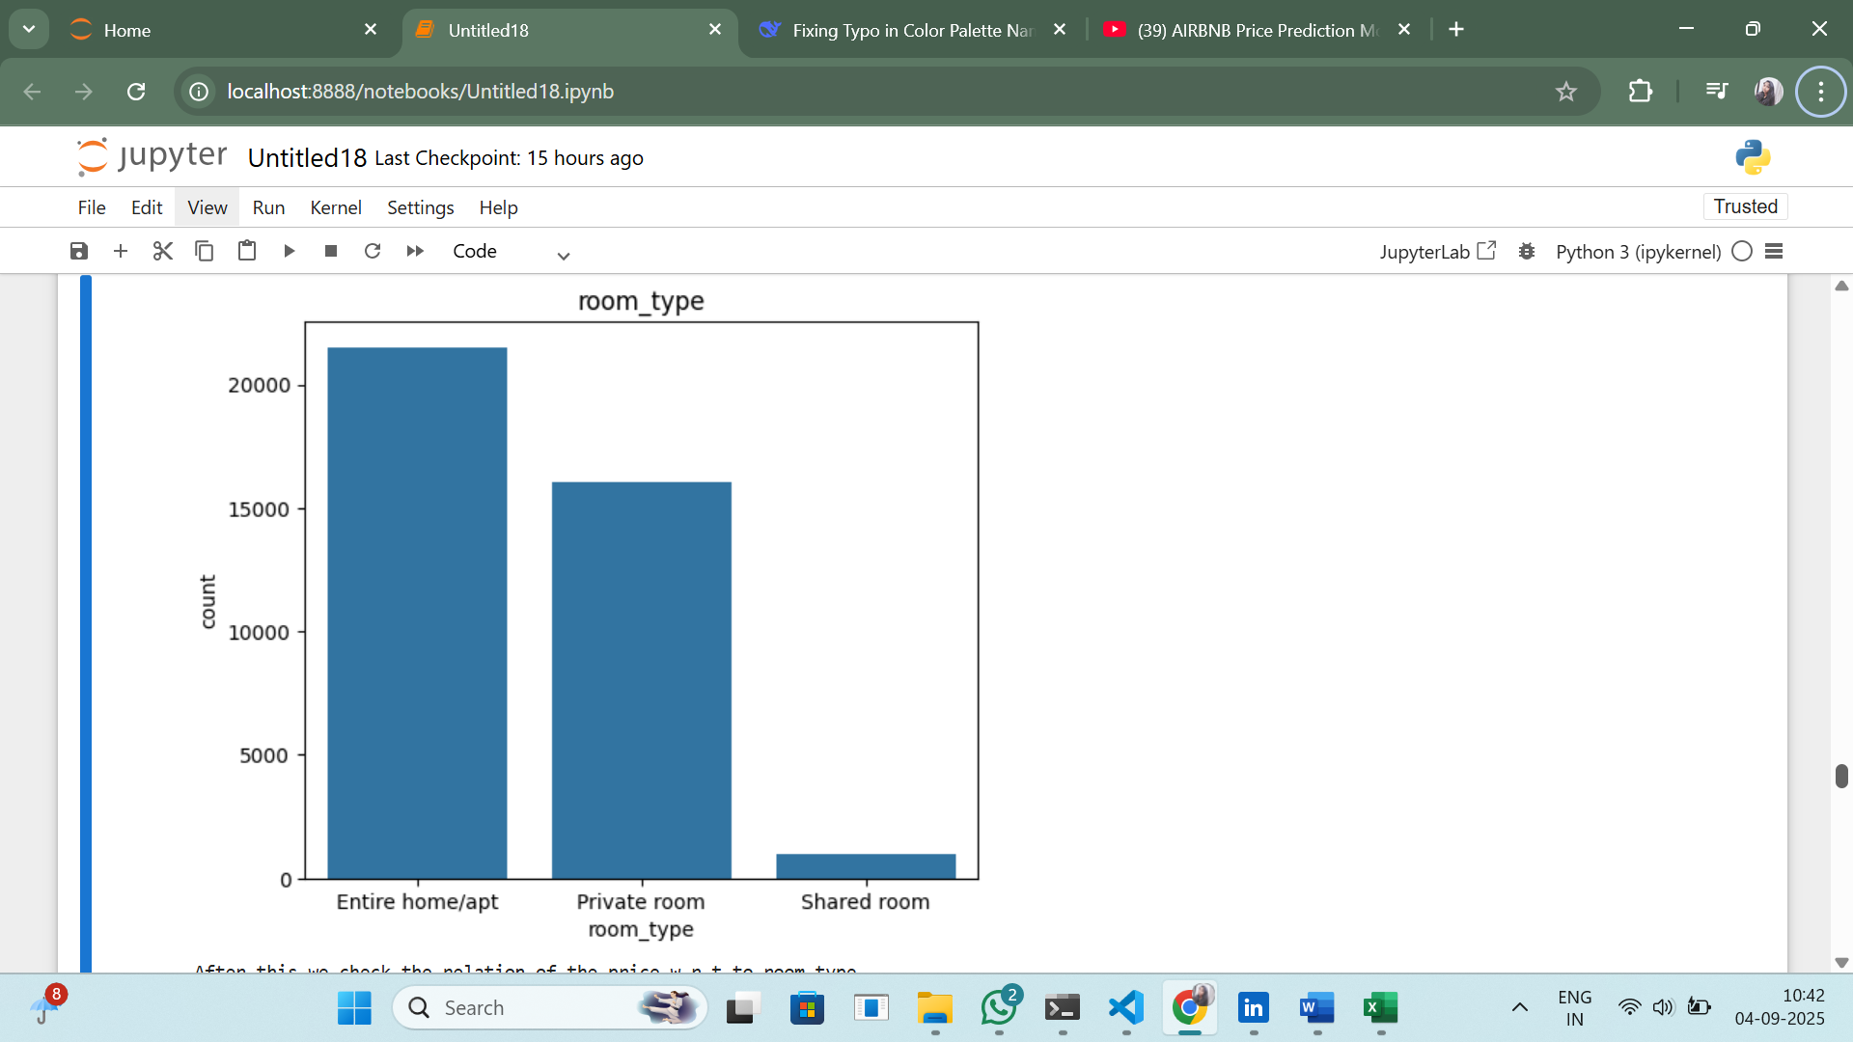

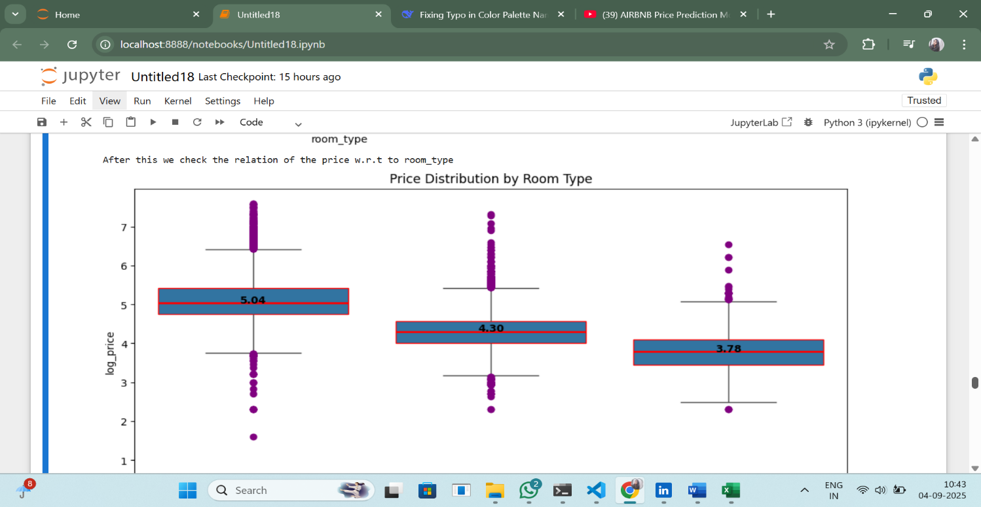

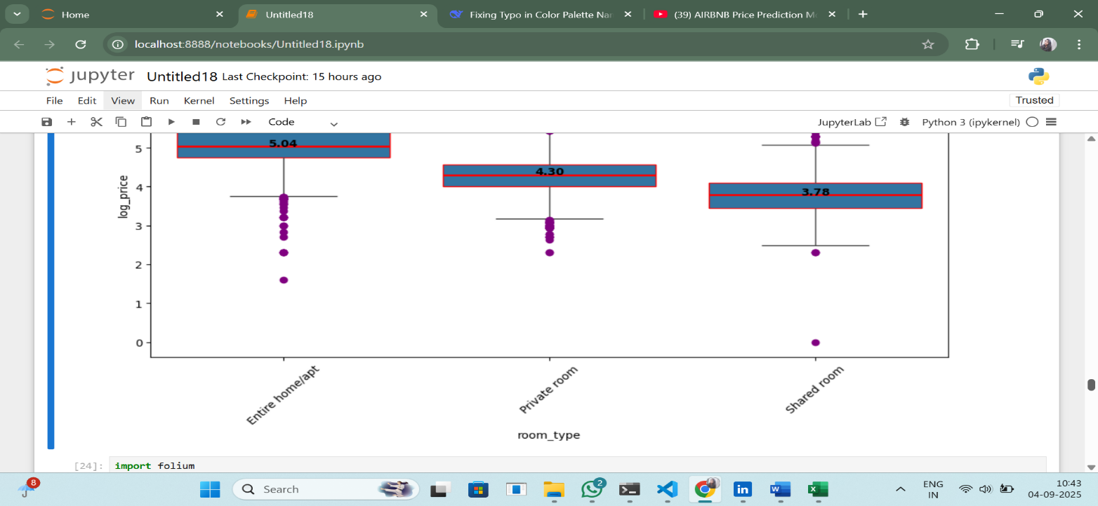

import folium

import pandas as pd

import branca.colormap as cm

# Create the map

m = folium.Map(location=[40.7128, -74.0060], zoom_start=11)

# Filter your DataFrame correctly (maybe you meant <=1000 & >=10000? but I'll keep your logic).

filtered_price = airbnb[(airbnb['log_price'] <= 1000) & (airbnb['log_price'] <= 10000)]

# Define your colormap properly using scalar vmax

price_color_scale = cm.LinearColormap(

['green', 'yellow', 'red'],

vmin=filtered_price['log_price'].min(),

vmax=filtered_price['log_price'].max()

)

# Add circle markers with appropriate colors

for index, row in filtered_price.iterrows():

folium.CircleMarker(

location=[row['latitude'], row['longitude']],

radius=5,

color=price_color_scale(row['log_price']),

fill=True,

fill_color=price_color_scale(row['log_price']),

fill_opacity=0.6,

popup=f"log_price: ${row['log_price']:.2f}<br>Room_type: {row['room_type']}",

).add_to(m)

# Add color scale legend to map

price_color_scale.add_to(m)

# Display

m

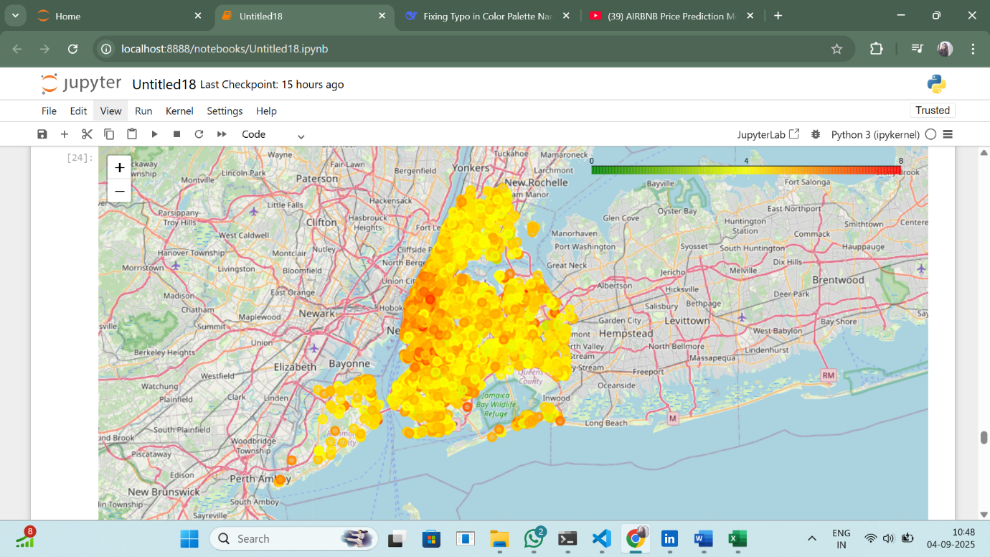

Room_Type Vs Log_Price

sns.countplot(airbnb_copy['room_type'],palette="plasma")

fig=plt.gcf()

fig.set_size_inches(5,5)

plt.show()

print("Lets compare the room type effect on the log_price")

plt.figure(figsize=(15,12))

sns.scatterplot(x='room_type',y='log_price',data=airbnb)

plt.xlabel("Room Type",size=13)

plt.ylabel("Log_Price",size=13)

plt.title("Room Type Vs Log Price",size=15,weight='bold')

plt.show()

print("This shows that the shared room is having less log price.Entire room is having the highest followed by private room")

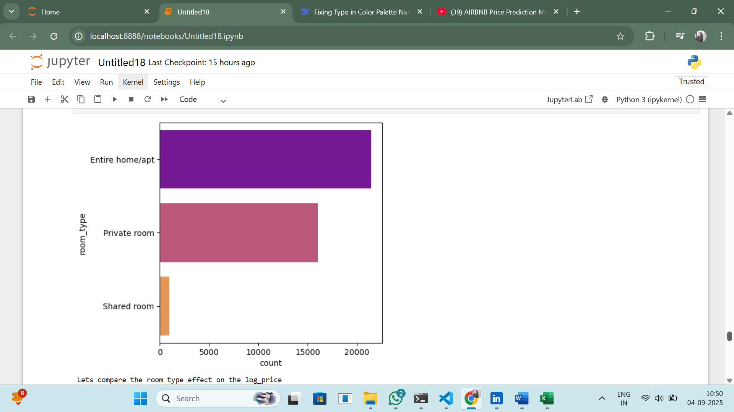

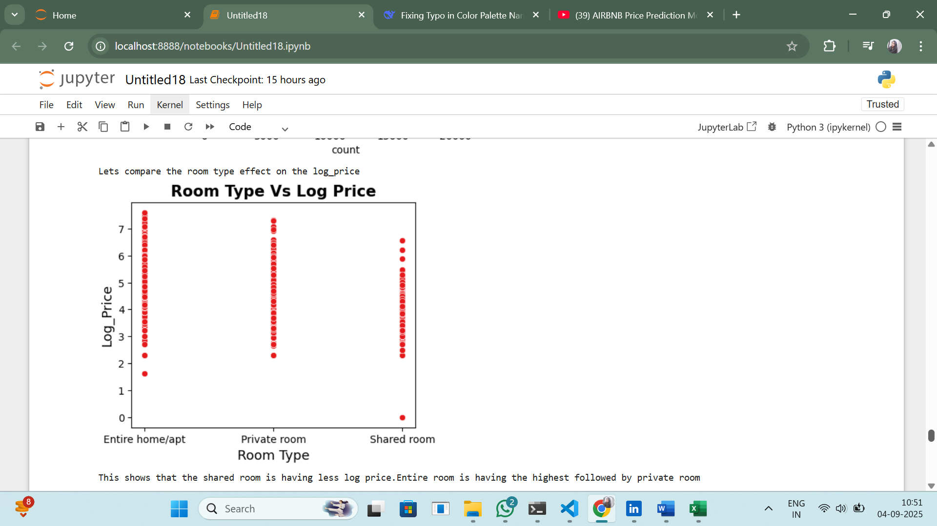

Room_Type VS Log_Price based on Property_Type

import matplotlib.pyplot as plt

import seaborn as sns

fig,axes=plt.subplots(2,2,figsize=(25,15))

fig.suptitle("Room_type Vs Log_price Vs property_type", fontsize=16,fontweight='bold')

room_types=airbnb_copy['room_type'].unique()

for i, room_type in enumerate(room_types):

row=i//2

col=i%2

ax=axes[row,col]

data_group = airbnb_copy[airbnb_copy['room_type']==room_type]

sns.scatterplot(x='property_type',y='log_price',hue='property_type',size='property_type',sizes=(50,200),palette='Dark2',data=data_group,ax=ax)

ax.set_title(f"Room Type : {room_type}")

ax.set_xlabel("Property_type")

ax.set_ylabel("Log_Price")

plt.tight_layout()

plt.subplots_adjust(top=0.9)

plt.show()



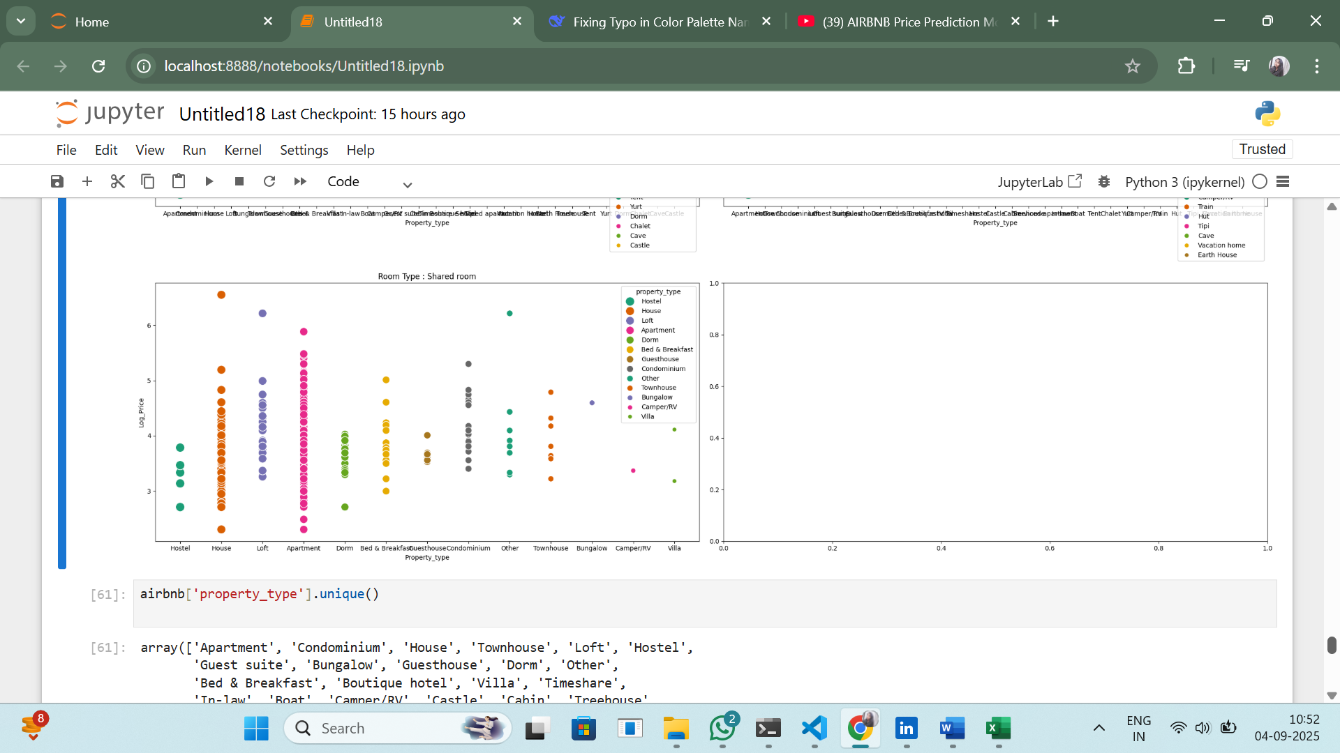

Log_price Vs Number_of_reviews Vs Property_type

plt.figure(figsize=(5,6))

sns.set_palette("Set1")

sns.lineplot(x='log_price',y='number_of_reviews',data=airbnb_copy[airbnb_copy['property_type']=='Apartment'], label='Apartment'),

sns.lineplot(x='log_price',y='number_of_reviews',data=airbnb_copy[airbnb_copy['property_type']=='Condominium'],label='Condominium'),

sns.lineplot(x='log_price',y='number_of_reviews',data=airbnb_copy[airbnb_copy['property_type']=='House'],label='House'),

sns.lineplot(x='log_price',y='number_of_reviews',data=airbnb_copy[airbnb_copy['property_type']=='Townhouse'], label='Townhouse'),

sns.lineplot(x='log_price',y='number_of_reviews',data=airbnb_copy[airbnb_copy['property_type']=='Loft'],label='Loft'),

sns.lineplot(x='log_price',y='number_of_reviews',data=airbnb_copy[airbnb_copy['property_type']=='Hostel'],label='Hostel'),

sns.lineplot(x='log_price',y='number_of_reviews',data=airbnb_copy[airbnb_copy['property_type']=='Guest Suite'], label='Guest Suite'),

sns.lineplot(x='log_price',y='number_of_reviews',data=airbnb_copy[airbnb_copy['property_type']=='Bungalow'],label='Bungalow'),

sns.lineplot(x='log_price',y='number_of_reviews',data=airbnb_copy[airbnb_copy['property_type']=='Dorm'],label='Dorm'),

sns.lineplot(x='log_price',y='number_of_reviews',data=airbnb_copy[airbnb_copy['property_type']=='Other'], label='Apartment'),

sns.lineplot(x='log_price',y='number_of_reviews',data=airbnb_copy[airbnb_copy['property_type']=='In-law'],label='In-law'),

sns.lineplot(x='log_price',y='number_of_reviews',data=airbnb_copy[airbnb_copy['property_type']=='Boat'],label='Boat'),

sns.lineplot(x='log_price',y='number_of_reviews',data=airbnb_copy[airbnb_copy['property_type']=='Camper/Rv'], label='Camper/Rv'),

sns.lineplot(x='log_price',y='number_of_reviews',data=airbnb_copy[airbnb_copy['property_type']=='Castle'],label='Castle'),

sns.lineplot(x='log_price',y='number_of_reviews',data=airbnb_copy[airbnb_copy['property_type']=='Cabin'],label='Cabin'),

sns.lineplot(x='log_price',y='number_of_reviews',data=airbnb_copy[airbnb_copy['property_type']=='Treehouse'], label='Treehouse'),

sns.lineplot(x='log_price',y='number_of_reviews',data=airbnb_copy[airbnb_copy['property_type']=='Serviced apartment'],label='Serviced apartment'),

sns.lineplot(x='log_price',y='number_of_reviews',data=airbnb_copy[airbnb_copy['property_type']=='Tipi'],label='Tipi'),

sns.lineplot(x='log_price',y='number_of_reviews',data=airbnb_copy[airbnb_copy['property_type']=='Hut'], label='Hut'),

sns.lineplot(x='log_price',y='number_of_reviews',data=airbnb_copy[airbnb_copy['property_type']=='Vacation home'],label='Vacation home'),

sns.lineplot(x='log_price',y='number_of_reviews',data=airbnb_copy[airbnb_copy['property_type']=='Tent'],label='Tent'),

sns.lineplot(x='log_price',y='number_of_reviews',data=airbnb_copy[airbnb_copy['property_type']=='Chalet'], label='Chalet'),

sns.lineplot(x='log_price',y='number_of_reviews',data=airbnb_copy[airbnb_copy['property_type']=='Yurt'],label='Yurt'),

sns.lineplot(x='log_price',y='number_of_reviews',data=airbnb_copy[airbnb_copy['property_type']=='Earth House'],label='Earth House'),

sns.lineplot(x='log_price',y='number_of_reviews',data=airbnb_copy[airbnb_copy['property_type']=='Train'],label='Train'),

sns.lineplot(x='log_price',y='number_of_reviews',data=airbnb_copy[airbnb_copy['property_type']=='Cave'],label='Cave')

plt.xlabel("Log_price",size=13)

plt.ylabel("Number of Reviews",size=13)

plt.title("Log_price Vs Number_of_Reviews Vs Property_type",size=15,weight='bold')

plt.show()

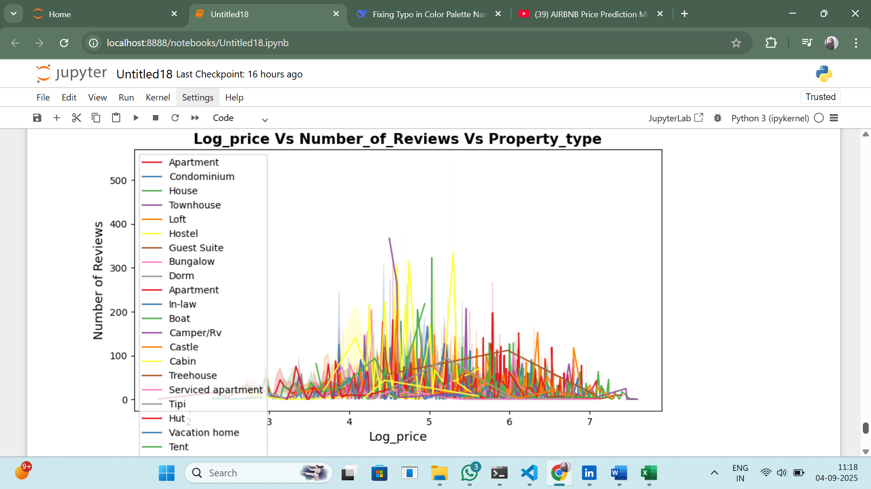

Log_Price Vs Bed_type

import folium

import pandas as pd

import branca.colormap as cm

m=folium.Map(location=[40.7128, -74.0060], zoom_start=11)

colors=['green','blue','purple','red','orange']

price_min=airbnb_copy['log_price'].min()

price_max=airbnb_copy['log_price'].max()

colormap=cm.LinearColormap(colors=colors,vmin=price_min, vmax=price_max)

for index, row in airbnb.iterrows():

folium.CircleMarker(

location=[row['latitude'], row['longitude']],

radius=5,

color=colormap(row['log_price']),

fill=True,

fill_color=colormap(row['log_price']),

fill_opacity=0.6,

popup=f"log_price: ${row['log_price']:.2f},bed_type: {row['bed_type']}",

).add_to(m)

colormap.add_to(m)

m

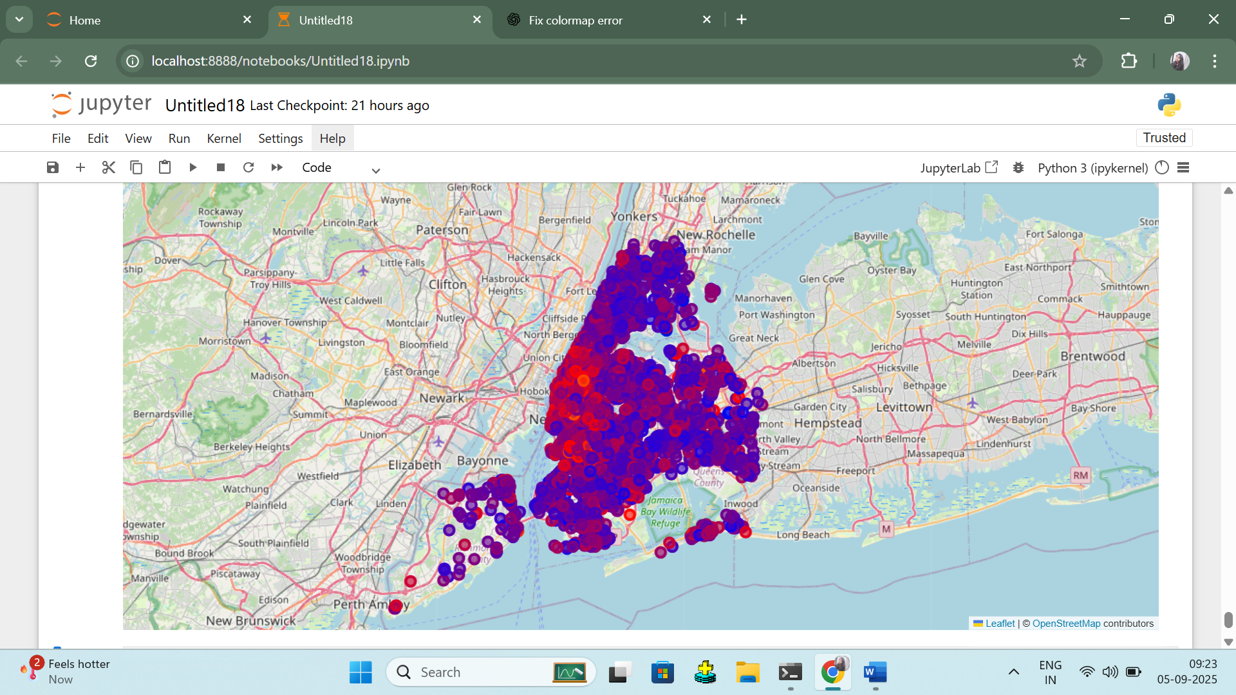

Data Modeling

airbnb_copy.head()

import matplotlib.pyplot as plt

plt.figure(figsize=(12,4))

plt.scatter(airbnb['host_response_rate'],airbnb['log_price'],alpha=0.5)

plt.title('Log_price Vs host_response_rate')

plt.xlabel('host_response_rate')

plt.ylabel('Log_price')

plt.grid(True)

plt.show()

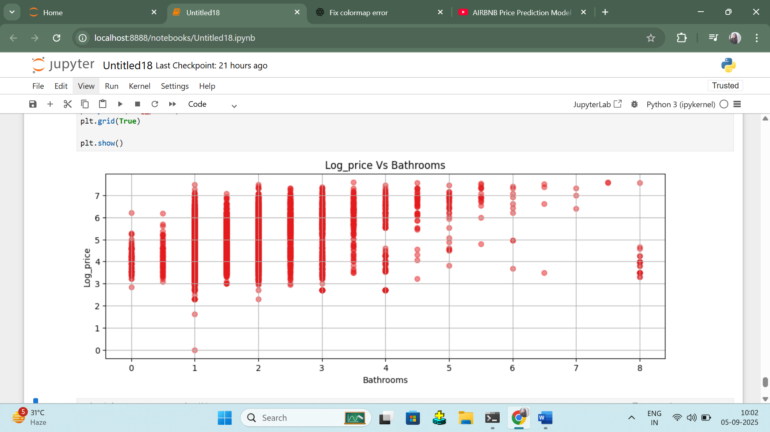

import matplotlib.pyplot as plt

from scipy.stats import norm

import seaborn as sns

plt.figure(figsize=(9,5))

sns.distplot(airbnb_copy['log_price'],fit=norm)

plt.title("Log_Price Distribution Plot",size=15,weight='bold')

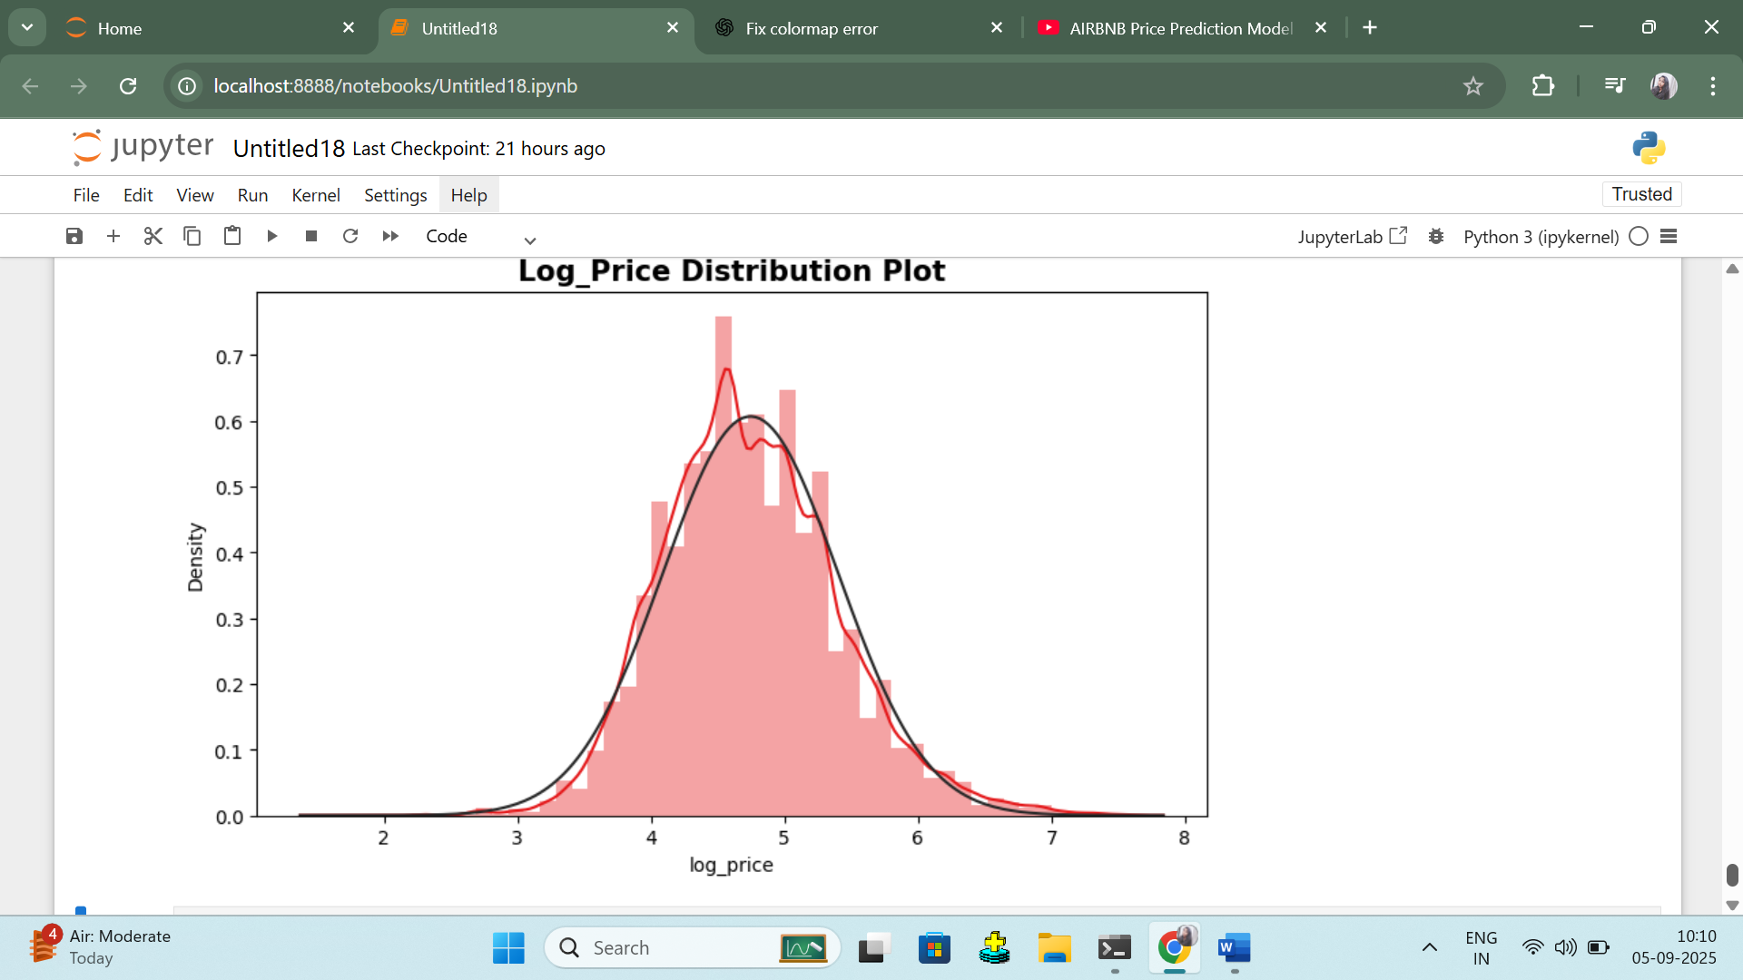

airbnb.head()

airbnb_copy.info()

airbnb_copy.drop(['latitude','longitude','neighbourhood','number_of_reviews'],axis=1,inplace=True)

airbnb_copy.isnull().sum()

Checking Multicollinearity

multicollinearity, v=np.linalg.eig(corr)

multicollinearity

Encoding the data

def Encode(airbnb_copy):

for column in airbnb_copy.columns[airbnb_copy.columns.isin(['neighbourhood','room_type'])]:

airbnb_copy[column]=airbnb_copy[column].factorize()[0]

return airbnb_copy

airbnb_copy_en=Encode(airbnb_copy.copy())

airbnb_copy_en.head()

#Import necessary libraries

import pandas as pd

from sklearn.model_selection import train_test_split

from sklearn.linear_model import LinearRegression,Lasso,Ridge

from sklearn.tree import DecisionTreeRegressor

from sklearn.metrics import r2_score

#Define independent and dependent variables

x=airbnb_copy_en.iloc[:,[0,1,3,4,5]]

y=airbnb_copy_en['log_price']

#Split the data into training and testing sets

x_train,x_test,y_train,y_test=train_test_split(x,y,test_size=0.1,random_state=353)

#Display a sample of the training data

print("Sample of x_train:")

print(x_train.head())

print("\nSample of y_train:")

print(y_train.head())

from sklearn.metrics import mean_squared_error, mean_absolute_error

import numpy as np

airbnb = airbnb.replace(r'\r+|\n+|\t+', '', regex=True)

#Create and train a linear Regression model

reg=LinearRegression()

reg.fit(x_train,y_train)

#Make predictions using the linear Regression model

y_pred_linear=reg.predict(x_test)

#Calculated and print the R-squared score for Linear Regression

linear_regression_r2=r2_score(y_test,y_pred_linear)

print("\nR-squared score for Linear Regression :",linear_regression_r2)

#calculate RMSE for linear Regression

linear_rmse=np.sqrt(mean_squared_error(y_test,y_pred_linear))

print("RMSE for Linear Regression :",linear_rmse)

#calculate MAE for linear Regression

linear_mae=mean_absolute_error(y_test,y_pred_linear)

print("MAE for Linear Regression :",linear_mae)

#Create a dataframe to display actual vs predicted values

comparison_airbnb=pd.DataFrame({'Actual':y_test,'Predicted':y_pred_linear})

#Print the DataFrame

print(comparison_airbnb)

